AUTOCOMPLETE WITH LIVE SEARCH  
 While searching, it will automatically filter the list of movies according to the inputs, other than that, **the search box will give you auto complete suggestions**, so you can either type an exact word, OR choose from the auto complete suggestion. This will be very handy if you are working with hundreds of data.

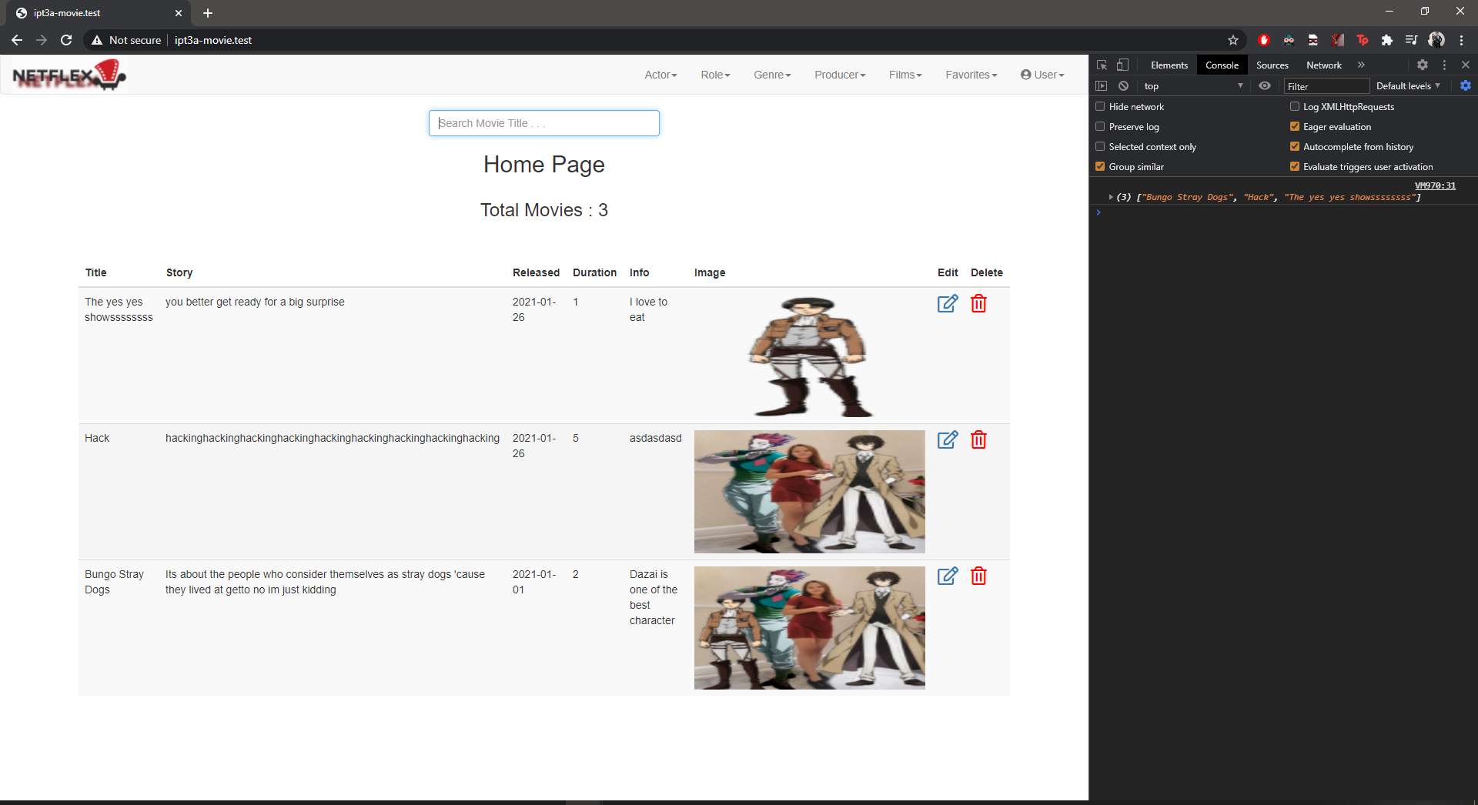

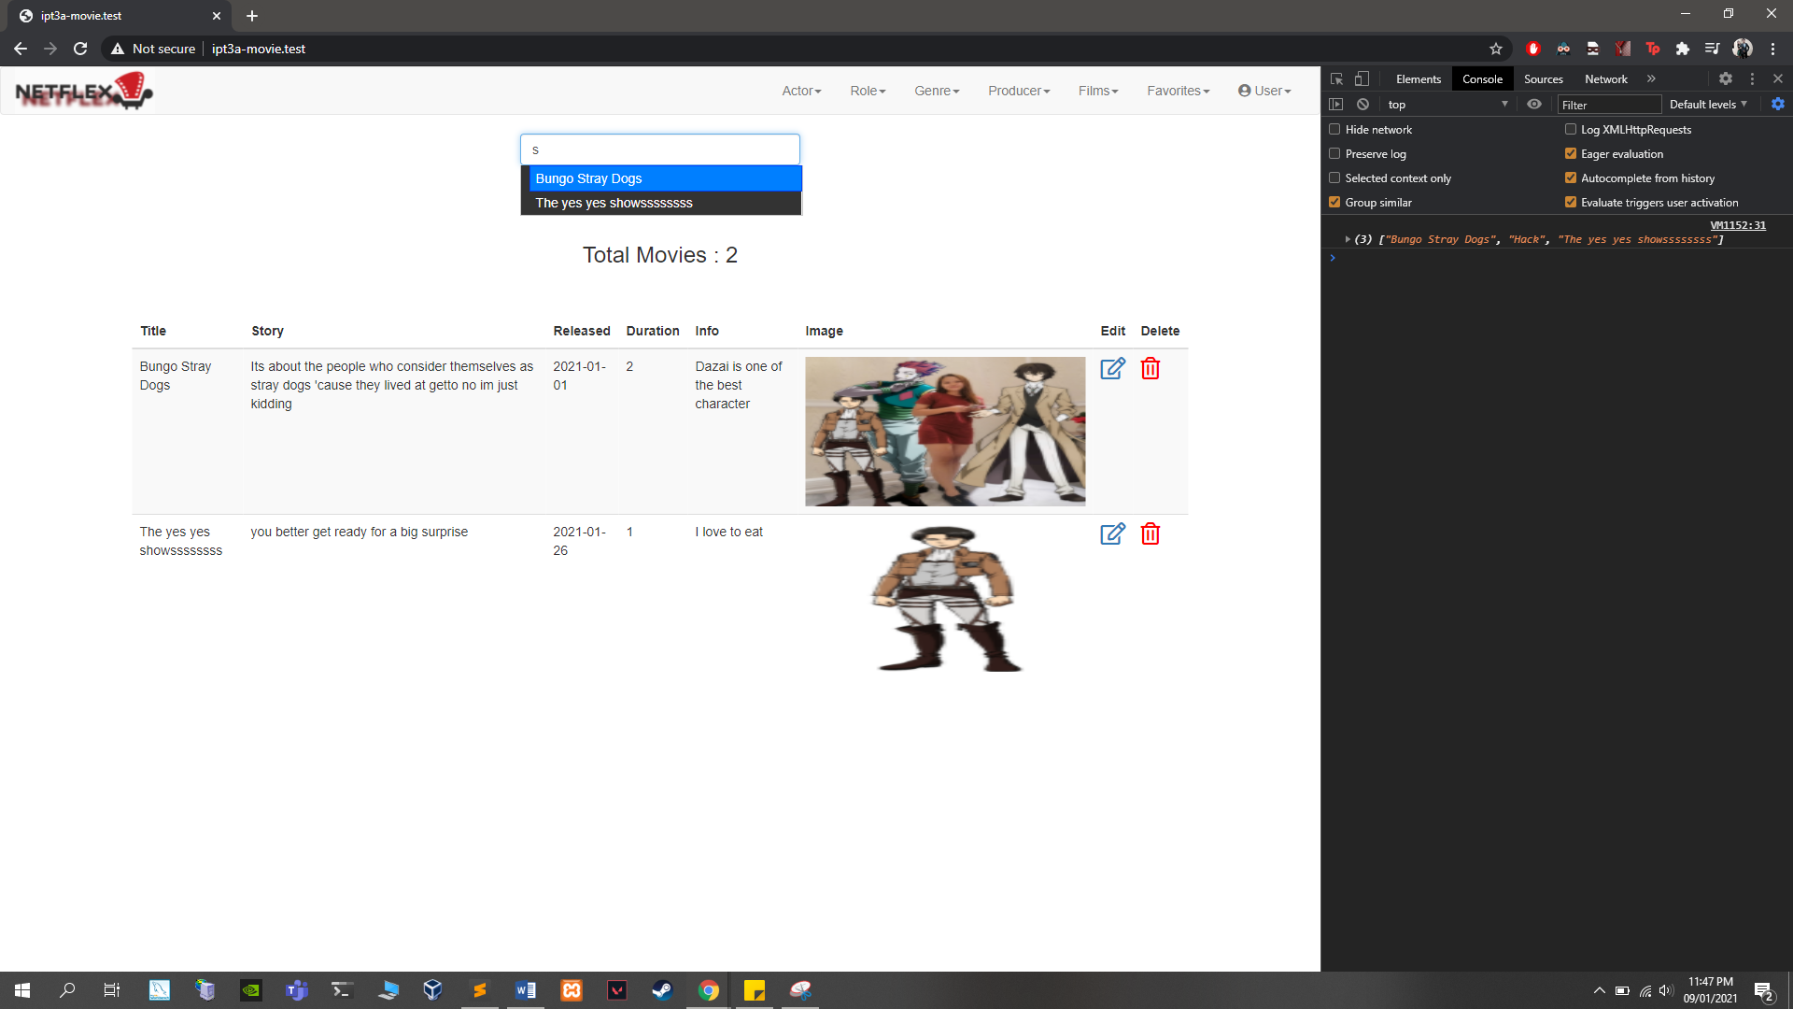

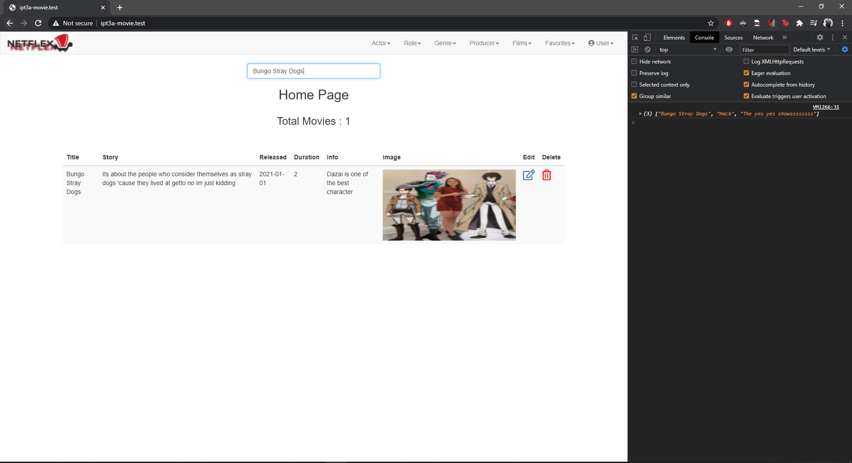

AUTOCOMPLETE





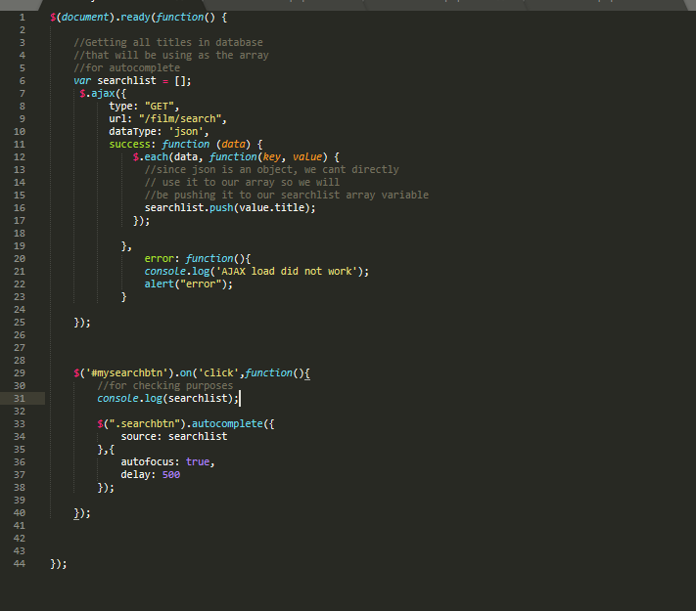



LIVE SEARCH

